Chapter 19, Problem 24.

Find the resistive circuit that represents these y parameters:

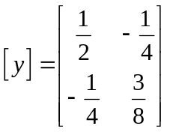S

